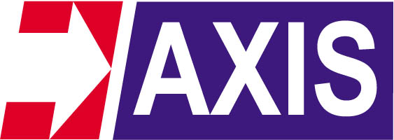

Ref:AEC/INTRO/11-12/001

Kind attn: The Business development Manager-Electrical Division

Dear sir,

AXIS an ISO9001 co is engaged in manufacturing and exports of wide range of
Electrical components and fittings

The products manufactured and supplied by AXIS are
- Cable lugs-Copper/Aluminium/Bimetallic -
- Mechanical Connectors
- Brass Cable Glands-
- Ground rods - Copper Bonded /Pure Cu/SS/Galv Steel
- Ground Clamps and accessories -
- Exothermic weld mtl amd moulds
- Lightning protection fittings -
- LV cable and Conductors fittings
- SS cable ties and tags
- Galvanised Pole line hardware
- OH line Clamps and Connectors
- LV & MV heat shrink products ( Supplies)
- Tailor made metal components & parts
All the above products are manufactured to international standards.
Our products are exported 58 countries & growing.

We wish to supply range of electrical products to your company. If you have any requirements on above listed products,please contact us with your enquiry

.
Thanking you,
Best regards
Nimish Taterh
Director Marketing

AXIS ELECTRICAL COMPONENTS I.P.LTD
(An ISO 9001 Co)
Axis House, Plot # 104C, Govt Indst Estate, Kandivali-West,
Bombay-400 067, India
Tel: 28696636 Fax: 28678491
marketing@axis-india.com

www.axis-india.com

Certificate Regn # 200 00284 QM08

